Dcoumentation Rest API + mongoDB menggunakan POSTMAN

1. Method GET

Url : http://localhot:8000/api/package

Hasil :

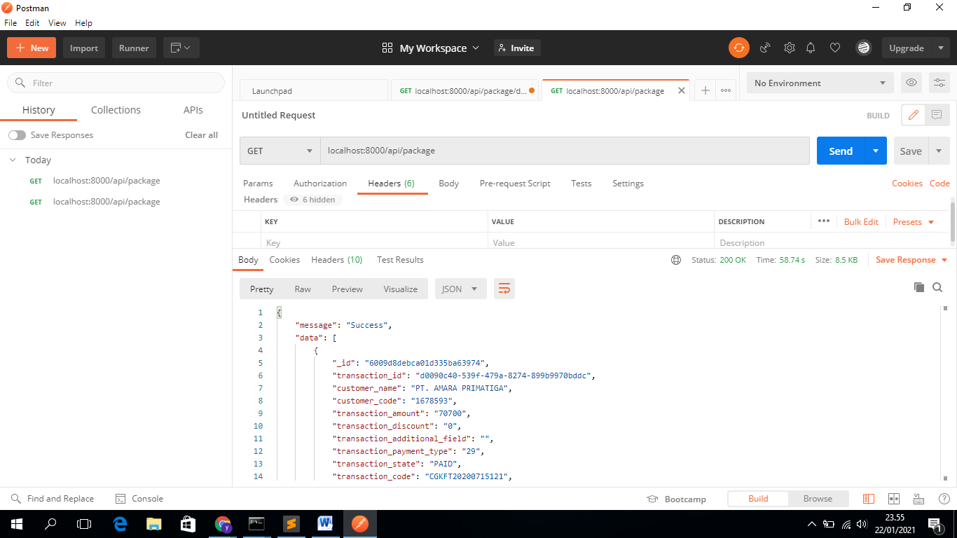

1. Method Get By ID

Url: [http://localhost:8000/api/package/{id}](http://localhost:8000/api/package/%7bid%7d)

Hasil:

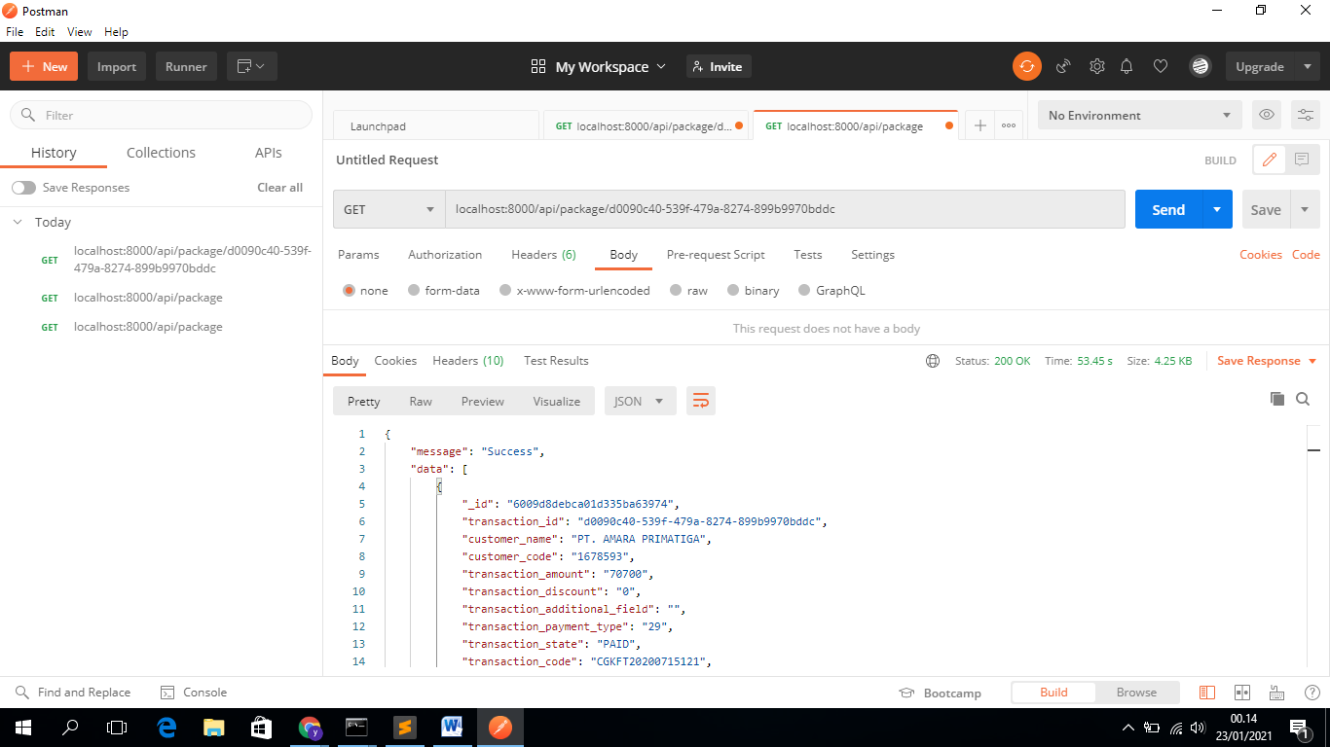

1. Method Post

Url: <http://localhost:8000/api/package>

Hasil:

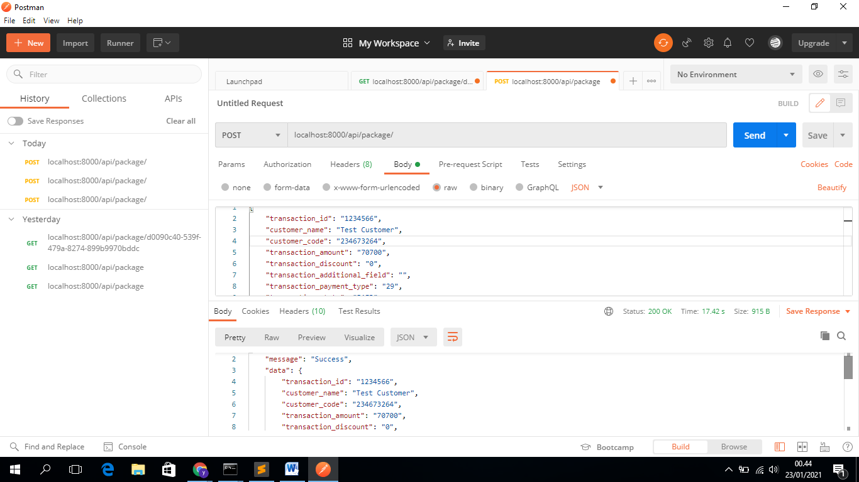

1. Method Put

Url : [http://localhost:8000/api/package/{id}](http://localhost:8000/api/package/%7bid%7d)

Hasil :

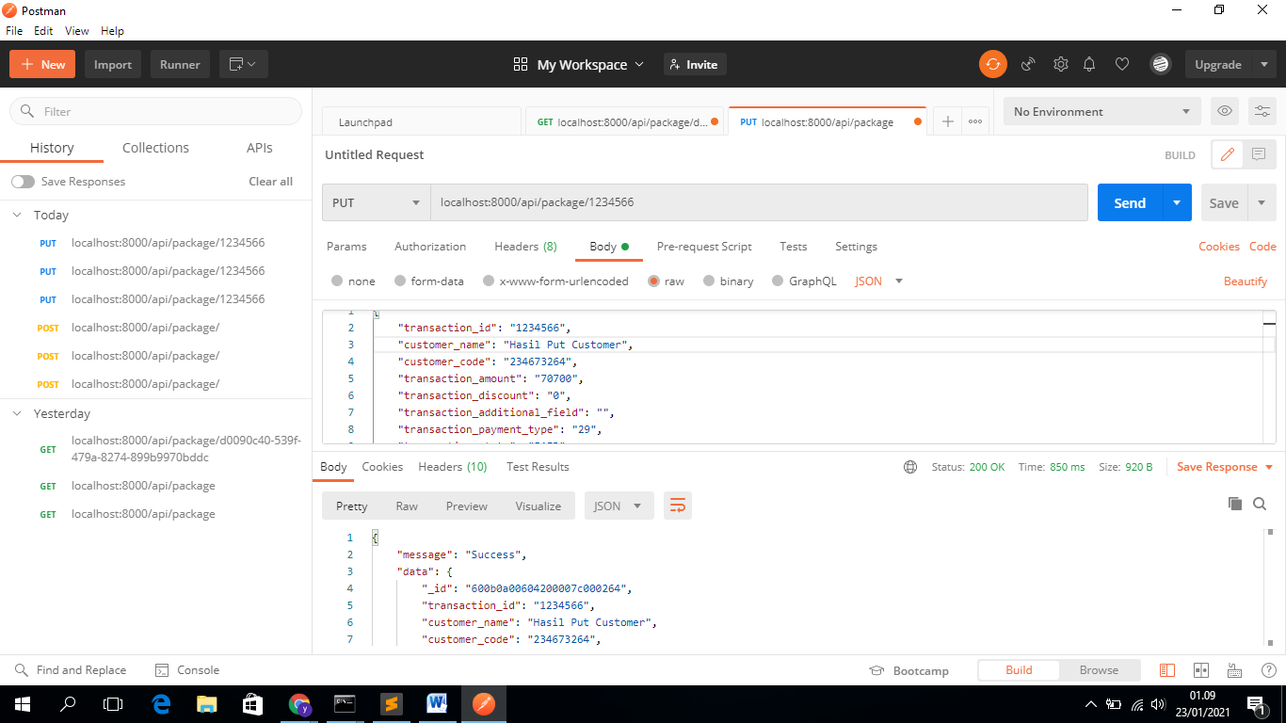

1. Method Patch

Url : [http://localhost:8000/api/package/{id}](http://localhost:8000/api/package/%7bid%7d)

Hasil :

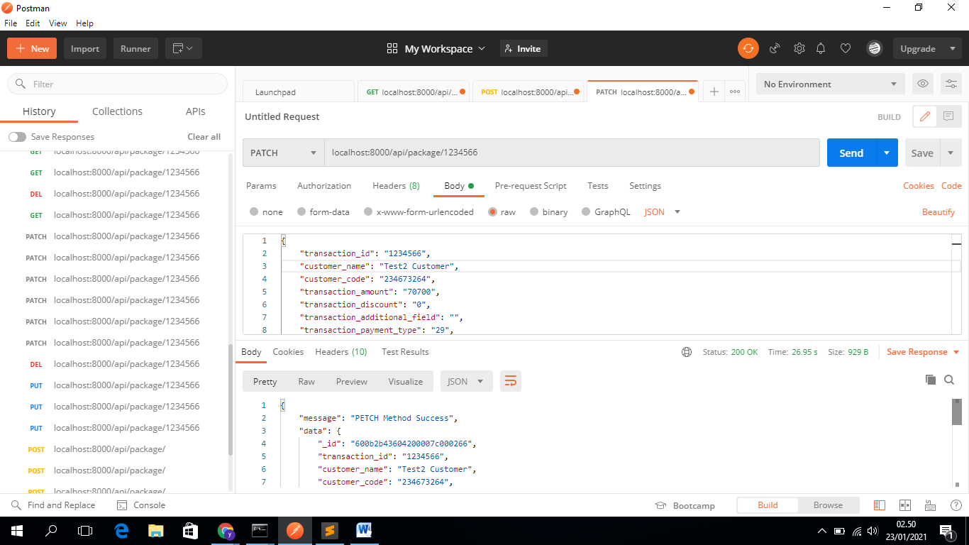

1. Method Delete

Url: [http://localhost:8000/api/package/{id}](http://localhost:8000/api/package/%7bid%7d)

Hasil:

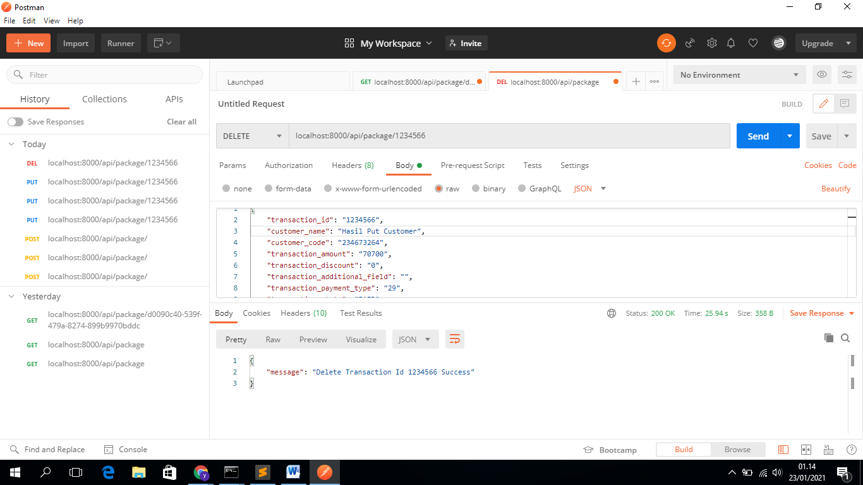

Unit Testing API

